座號：08 姓名：方宜馨

階段性作業八

商品管理綜合應用(前台介面)

* 請利用合適的各種控制項展現商品陳列，達到以下要求：
  1. 建立如參考畫面的樣式，模擬出如PChome等電商網站的使用者產品展示畫面。
  2. 利用之前學過的任何樣式處理方法，盡量編排出仿照電商網頁的樣式，用**前端或後端樣式處理方法皆可**。
  3. 商品圖樣與資料**需由資料庫中讀出來**，並且**未上架**的商品不予**顯示**。
  4. 需有**兩個**畫面，第一個為商品展示，點擊商品後可進入商品詳細資料畫面。
* 畫面編排樣式及商品內容僅供參考，無需完全一樣。

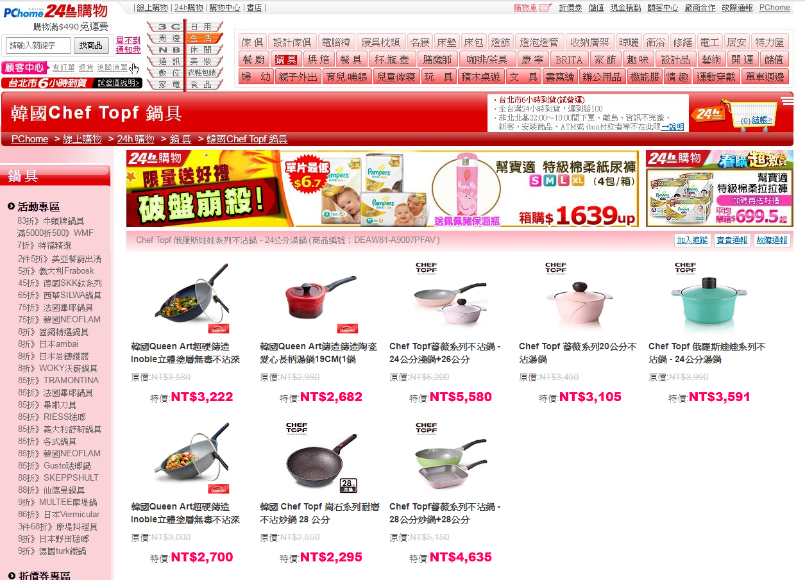

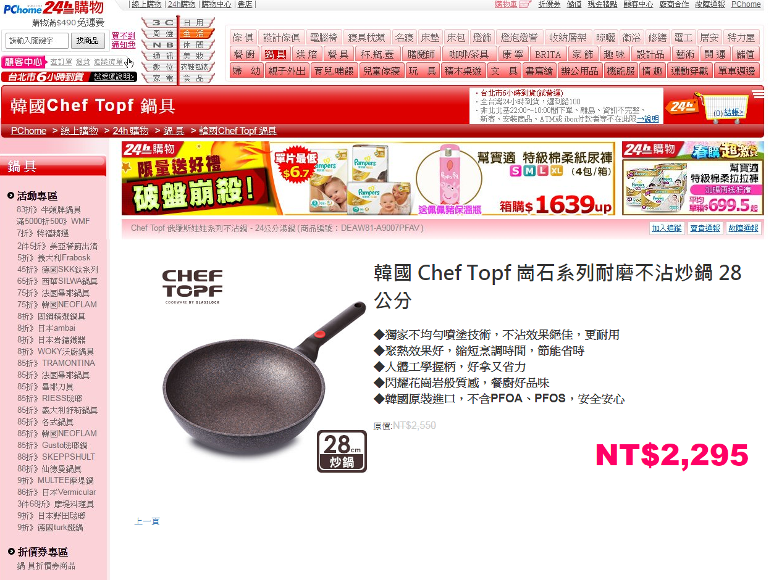

**繳交作業時，請以FTP上傳程式原始檔與本文件檔各一份，原始程式碼請另放置在一個資料夾內。**

※以上各項均須完成始得通過※

執行結果畫面截圖(至少兩個圖)：

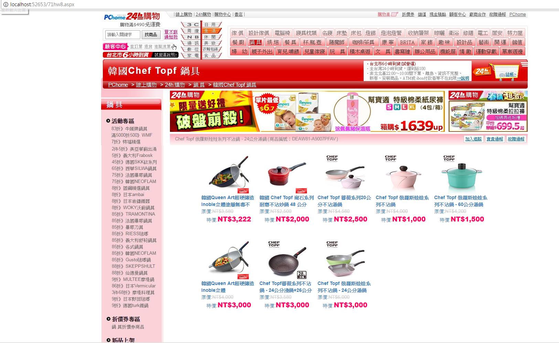

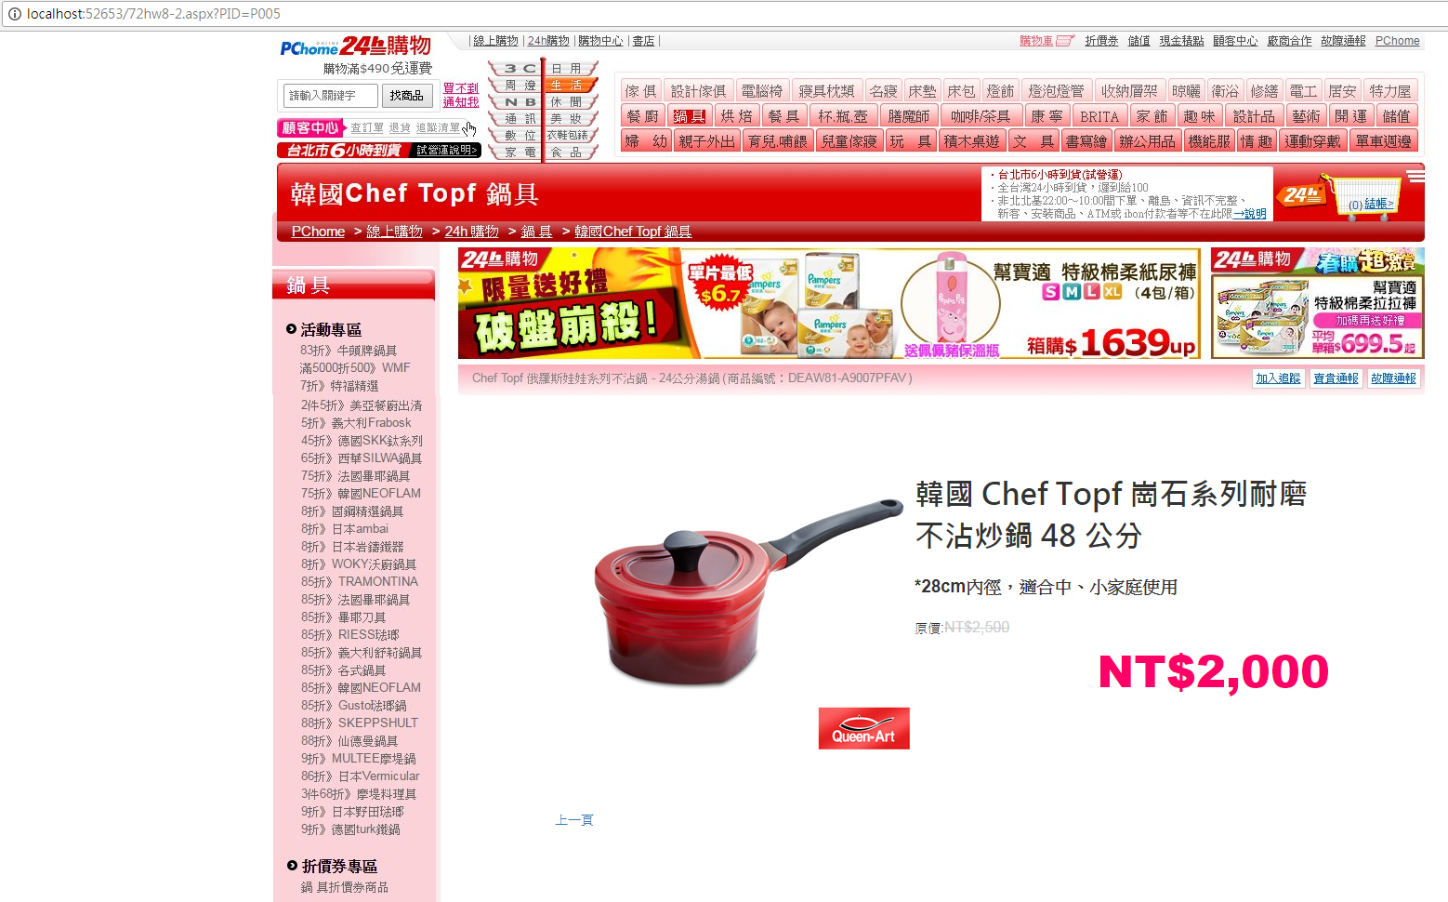

程式碼(所有的程式碼均須貼上)：

<%@ Page Title="" Language="C#" MasterPageFile="~/MasterPage.master" AutoEventWireup="true" CodeFile="71hw8.aspx.cs" Inherits="_71hw8" %>

<asp:Content ID="Content1" ContentPlaceHolderID="head" Runat="Server">

</asp:Content>

<asp:Content ID="Content2" ContentPlaceHolderID="ContentPlaceHolder1" Runat="Server">

<asp:SqlDataSource ID="SqlDataSource1" runat="server"

ConnectionString="<%$ ConnectionStrings:ScoresConnectionString %>"

SelectCommand="SELECT * FROM [Products] where Product_Status=1"></asp:SqlDataSource>

<asp:DataList ID="DataList1" RepeatColumns="5" runat="server"

DataKeyField="Product_ID" DataSourceID="SqlDataSource1" BorderWidth="0" Width="100%"

ItemStyle-Height="250" ItemStyle-Width="250">

<ItemTemplate>

<a href='72hw8-2.aspx?PID=<%# Eval("Product_ID") %>'>

<table style="width: 95%; height:95%">

<tr>

<td class="text-center">

<img src='ProductsImg/s<%# Eval("Img") %>.jpg' />

</td>

</tr>

<tr>

<td>

<asp:Label ID="Product_NameLabel" Font-Bold="true" runat="server" Text='<%# Eval("Product_Name") %>' />

</td>

</tr>

<tr>

<td>

原價:<asp:Label ID="Label1" ForeColor="#cccccc" runat="server" Text='<%# Eval("Product_Price","{0:C0}") %>' style="text-decoration:line-through" />

</td>

</tr>

<tr>

<td class="text-center">

特價:<asp:Label ID="Product_Price2Label" Font-Names="Arial Black" Font-Size="14pt" ForeColor="#ff0066" runat="server" Text='<%# Eval("Product_Price2","{0:C0}") %>' />

</td>

</tr>

</table>

</a>

</ItemTemplate>

</asp:DataList>

</asp:Content>

<%@ Page Title="" Language="C#" MasterPageFile="~/MasterPage.master" AutoEventWireup="true" CodeFile="72hw8-2.aspx.cs" Inherits="_72hw8_2" %>

<asp:Content ID="Content1" ContentPlaceHolderID="head" Runat="Server">

</asp:Content>

<asp:Content ID="Content2" ContentPlaceHolderID="ContentPlaceHolder1" Runat="Server">

<asp:SqlDataSource ID="SqlDataSource1" runat="server"

ConnectionString="<%$ ConnectionStrings:ScoresConnectionString %>"

SelectCommand="SELECT * FROM [Products] where Product_ID=@Product_ID">

<SelectParameters>

<asp:QueryStringParameter Name="Product_ID" QueryStringField="PID" Type="String" />

</SelectParameters>

</asp:SqlDataSource>

<asp:Repeater ID="Repeater1" runat="server" DataSourceID="SqlDataSource1">

<ItemTemplate>

<table style="width: 100%;height:500px">

<tr>

<td style="width:400px;text-align:right">

<img src='ProductsImg/<%# Eval("Img") %>.jpg' />

</td>

<td>

<asp:Label ID="Product_NameLabel" Font-Size="24pt" Font-Names="微軟正黑體" Font-Bold="true" runat="server" Text='<%# Eval("Product_Name") %>' /><br /><br />

<asp:Label ID="Label1" Font-Bold="true" Font-Size="14pt" runat="server" Text='<%# Eval("Product_Intro").ToString().Replace("\n","<br>") %>' /><br /><br />

原價:<asp:Label ID="Label2" Font-Size="12pt" ForeColor="#cccccc" runat="server" Text='<%# Eval("Product_Price","{0:C0}") %>' style="text-decoration:line-through" /><br />

<asp:Panel ID="Panel1" runat="server" Font-Names="Arial Black" HorizontalAlign="Right" Font-Size="36pt" ForeColor="#ff0066"><%# Eval("Product_Price2","{0:C0}") %></asp:Panel>

</td>

</tr>

<tr>

<td colspan="2">

<a href="71hw8.aspx" class="btn btn-link">上一頁</a>

</td>

</tr>

</table>

</ItemTemplate>

</asp:Repeater>

</asp:Content>

<%@ Master Language="C#" AutoEventWireup="true" CodeFile="MasterPage.master.cs" Inherits="MasterPage" %>

<!DOCTYPE html>

<html xmlns="http://www.w3.org/1999/xhtml">

<head runat="server">

<meta http-equiv="Content-Type" content="text/html; charset=utf-8"/>

<title></title>

<asp:ContentPlaceHolder id="head" runat="server">

</asp:ContentPlaceHolder>

<link href="Content/bootstrap.min.css" rel="stylesheet" />

</head>

<body>

<form id="form1" runat="server">

<div class="container">

<div class="row">

<div class="col-xs-12">

<img src="images/TOP.jpg" />

</div>

</div>

<div class="row">

<div class="col-xs-3">

<img src="images/LEFT.jpg" />

</div>

<div class="col-xs-9">

<asp:ContentPlaceHolder id="ContentPlaceHolder1" runat="server">

</asp:ContentPlaceHolder>

</div>

</div>

<div class="row">

<div class="col-xs-12">

<img src="images/BOTTOM.jpg" />

</div>

</div>

</div>

</form>

</body>

</html>